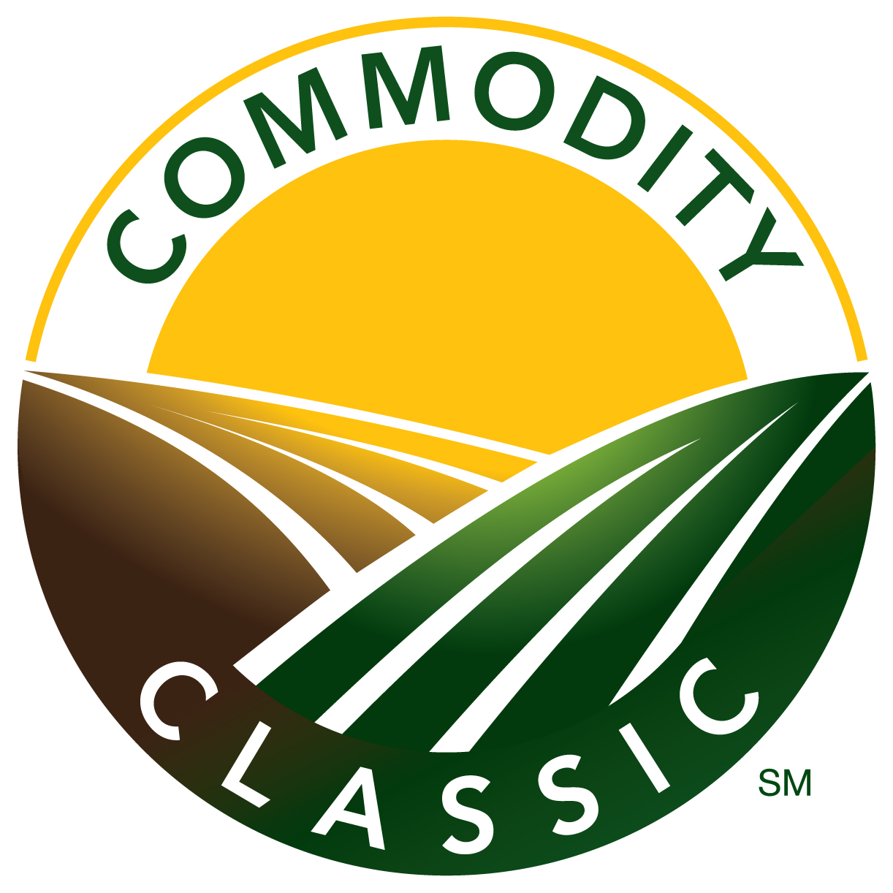 |  | Mini What’s New Sessions  Request for Proposals  2017 Commodity ClassicSM  San Antonio, Texas March 2 – 4, 2017
What is a Mini What’s New Session?
Mini What’s New Sessions are a unique opportunity for exhibiting companies to highlight their newest, most innovative product or service to the Commodity Classic attendees. Five-minute presentations – in a fast-paced 90-minute window of back-to-back presenters – give the audience a brief introduction to key developments and inventions. With attendance at 2017 Commodity Classic expected to surpass 9,000, you'll certainly want to share your news.
Who: | Commodity Classic 2017 exhibitors with a new product or service to introduce
What: | Mini What’s New Sessions are an abbreviated version of the 40-minute What’s New Sessions. Each presentation will be no more than five minutes in length. Commodity Classic will provide a moderator to introduce the speaker and keep the presentations on schedule. Mini What’s New Sessions have an ideal time slot, slated before the Grand Opening of the Trade Show. Your company and title of your presentation will be listed in the Commodity Classic onsite program booklet, website, and mobile app.
Where: | Henry B. Gonzalez Convention Center, San Antonio, Texas
Date: | Thursday, March 2, 8:15 a.m. - 9:45 a.m., repeats 10:00 a.m. - 11:30 a.m.  Note: Times are subject to change.
Fee: | $1,500 for two 5-minute time slots, scheduled during the above sessions
How: | Present a product or service introduced to the market no earlier than March 5, 2016. Please detail what makes this product new. How will the technology impact farming? Please forward information, even if the product or service is currently pending regulatory approval. Once a product or service is presented as a What’s New or Mini What’s New Session, it will not be eligible to be presented as one in future years.  Regarding submission of crop protection products, a totally new compound of new and older chemistry is acceptable. Existing chemistry with simply a new commercial name is not an acceptable submission.  Complete and return this Request for Proposal (RFP) to the address below no later than October 21, 2016.  Completed RFPs will be forwarded to the Commodity Classic Grower Committee for final selection in November. An invoice will be sent upon notification of selection.
What Attendees are Saying About Mini What’s New Sessions:
“Helps me decide where to stop in the trade show.”

“This was a very good overview of what’s new – long enough to get me interested to go ask more questions
at the trade show. Thanks!”

“Nice fast paced format. Very interesting and worth the time.”

"Extremely helpful in giving me an overall view of products and guidance as to which What’s New Sessions to attend."

“Whets the appetite to inquire for more at trade show.”

"I like the short blasts from many different ag areas."
Proposals must be submitted by Friday, October 21, 2016 to:
Abby Podkul, Commodity Classic, 12125 Woodcrest Executive Drive, Suite 100, St. Louis, MO 63141
apodkul@soy.org (314) 754-1345 direct line

2017 Commodity ClassicSM Mini What’s New RFP
Reminder: Company must be an exhibitor in the 2017 Commodity Classic in order to present a Mini What’s New Session.
Name: |  |  | Phone:
Title: |  |  | Fax:
Company: |  |  | E-mail:
Address:
City: |  | State: |  | Zip:
The Commodity Classic Grower Committee will make the final selection of sessions.
Selection will be based upon:
*Uniqueness of product/service *Value of product/service to agriculture
*Appeal of product/service to Commodity Classic audience *Supporting details included with RFP *Introduction date
Note: Product or service to be previewed at a 2017 Mini What’s New Session may be placed on market
no earlier than March 5, 2016.
Proposed Mini What’s New Session Title:

Product/Service Name and Description (Explain the product/service in detail and how it impacts farming):

Date Introduced to Market:
To be introduced at Commodity Classic? |  |  |  | Yes |  | No
Mini What’s New Session Outline (Summary of presentation; attach information if necessary):

Mini What’s New Session Presenter Name / Title / Experience:

Mini What’s New Session Title and Sponsor Name for Program Booklet and website (no descriptions):
Due December 16, 2016

Sponsorship Fee: $1,500 for 5-minute session plus a repeat 5-minute session

NOTE: | Exchange of payment for products/services during Mini What’s New Sessions is strictly prohibited.  Commodity Classic and its designated vendors shall have exclusive rights to record sessions unless otherwise agreed. All sessions and public events conducted at Commodity Classic, and recordings of such sessions, are property of Commodity Classic and may not be reproduced or disseminated in part or their entirety without the express written consent from Commodity Classic. Cameras are not permitted. Sponsors and speakers must return a signed copy of the Commodity Classic Presentation Recording and Use Policy.  REFUND POLICY: Please note that once Commodity Classic sponsorships are confirmed, they are non-cancelable and non-transferable. Commodity Classic also reserves the right to modify or cancel sponsored events upon notice to sponsors and pro rata adjustment to or refund of sponsorship fees.
Proposals must be submitted by Friday, October 21, 2016 to:
Abby Podkul
Commodity Classic
12125 Woodcrest Executive Drive, Suite 100
St. Louis, MO 63141
apodkul@soy.org (314) 754-1345 direct line

